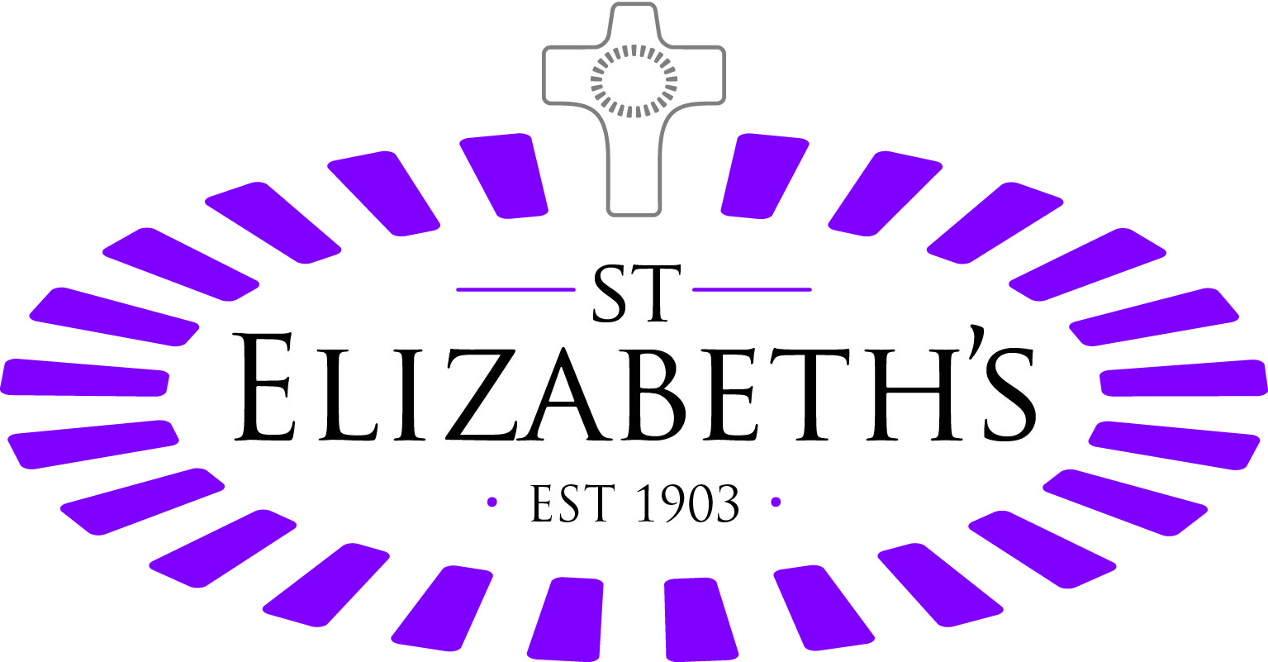

Aspirational ● Creative ● Collaborative ● Joyful ● Compassionate

Role Description
Role title | Trustee – Finance, Audit and Risk Committee Member/Investment Committee Member
Location | St Elizabeth’s Centre, SG10 6EW
Responsible to | The Board of Trustees
Accountable to | Chair of Trustee Board
St Elizabeth’s Centre
Based across 60 acres of beautiful countryside in Much Hadham, Hertfordshire, St Elizabeth's Centre is a charity supporting children, young people and adult day clients with epilepsy and other complex medical conditions, the severity of which impacts upon their health, social, behaviour, learning and emotional development.
Our Trustee Code
Our trustees are legally responsible for our management and administration. They play an important role in ensuring that our resources are used effectively to achieve our main objectives. We need our Trustees to lead us in offering vulnerable people individually designed education, care and support services that maximise their opportunities to live life to the full in the context of our Catholic faith and mission. In practice this means that you will:

- Take responsibility for the organisation, managing it well, making difficult decisions and leading by example.
- Have a clear understanding of the organisation, the Trustee role, and the responsibilities that it brings.
- Keep our mission at the heart of all that we do.
- Be honest about performance, being committed to working well together and ready to improve to deliver impact.
- Act with integrity and independence of mind aligned to our mission.
- Act and behave fairly, openly, and transparently, welcoming accountability, listening, and responding with insight.
The Role of a Trustee
As a Trustee of St Elizabeth’s, you will play a key role in shaping the future of the charity and supporting its long-term sustainability. Responsibilities include:
- Upholding the highest standards of charity governance as set out by the Charity Commission.
- Contributing to the strategic planning and direction of the organisation.
- Monitoring executive performance against strategic and operational plans.
- Identifying, assessing, and monitoring organisational risks.
- Participating fully and constructively in Board and committee meetings.
- Building positive, collaborative relationships with fellow Trustees and senior staff.
- Acting as an advocate and ambassador for St Elizabeth’s and its mission.
- Upholding or supporting the Catholic ethos of the charity.
- Using your networks to support fundraising, influence, and partnership development.
- Asking challenging, strategic questions while welcoming challenge in return
Skills and Expertise We Are Seeking
We are specifically seeking one or more Trustees with strong experience in finance and audit who will sit on our Finance, Audit & Risk Committee, and Investment Committee.

Finance, Audit & Risk Committee responsibilities include:
- Oversight of risk management, governance, and internal control arrangements.
- Reviewing economy, efficiency, and effectiveness across the organisation.
- Overseeing external audit processes.
- Ensuring appropriate systems, policies and controls comply with statutory and regulatory requirements.

Investment Committee responsibilities include:
- Developing and overseeing the charity’s investment policy.
- Ensuring the effective and efficient implementation of investment decisions.
- Maintaining the long-term real value of capital.
- Generating sustainable returns to support operations and strategic priorities

Legal Responsibilities of Trustees
Trustees must:
Ensure the charity is solvent, well run and delivering its charitable objectives.
- Ensure that funds are used appropriately and not placed at undue risk.
- Ensure compliance with law, regulation, and charity governance requirements.
- Act with integrity and avoid conflicts of interest.
- Commit to ongoing governance and skills development.

The Commitment

You will be expected to attend approximately five Board meetings each year. Typically, four of these meetings last around half a day, with one extended full-day session. Trustees are also required to sit on at least one Board committee, which generally meets between four and six times annually.
In addition to attending meetings, you will need to prepare by reviewing Board and committee papers circulated in advance. From time to time, you may also be asked to visit our site to support monitoring activities.
We will provide a comprehensive induction and ongoing training to ensure you can carry out your responsibilities effectively. Training may take place remotely or face-to-face and usually equates to around one day per year.
Board and committee meetings are usually held at our Much Hadham site; however, we recognise that personal or professional commitments may occasionally require remote attendance.
Although this is an unpaid voluntary role, we reimburse reasonable travel expenses.
Trustees are appointed for an initial four-year term, with the possibility of renewal for a further four years following a review of performance.

Other

St Elizabeth’s Centre is committed to safeguarding and promoting the welfare of children, vulnerable adults, and young people. The successful applicant(s) will be required to undertake an enhanced disclosure through the Disclosure and Barring Service. St Elizabeth’s Centre is proud to be recognised as an Investor in People and to hold Disability Confident status. We are an equal opportunities employer, and we welcome applications from across the community.
Some of our positions involve regulated activity relevant to vulnerable children, adults, and young people. It is a criminal offence for people who are barred from working in regulated activity to apply for roles that require them to work unsupervised with that particular group. Our vacancies are exempt from the Rehabilitation of Offenders Act 1974.

The post holder will take responsibility for safeguarding and promoting the welfare of children, vulnerable adults, and young people within the scope of the role.




Personal Qualities
Trustee | Essential | Desirable
Knowledge, Experience & Understanding
Practising Catholic, or committed to upholding the Catholic ethos of the charity
Professional experience (demonstrated, if possible, by a relevant qualification) at a senior level in the financial sectors (such as banking or accountancy)
Not disqualified from acting as a Trustee
Experience at a senior level within an organisation
An accounting/auditing qualification (for Trustees who sit on the Finance Audit & Risk Committee) or experience in formulating, overseeing, and reviewing investments
Good understanding of the role of a board director and charity trustee
Experience in developing a strategy and making policy
Good knowledge of Care Quality Commission ("CQC") standards and/or Office for Standards in Education, Children’s Services and Skills ("Ofsted")
Skills & Abilities
High ethical standards and a commitment to corporate governance principles
Ability to work collaboratively with other trustees and senior executives
Sound judgment and the ability to provide independent, objective advice
Excellent communication, interpersonal and leadership skills
Strong understanding of business operations, finance, and corporate strategy
Special Circumstances
Commitment to the work of St Elizabeth’s Centre
Commitment to equality, promoting respect and dignity for all
Commitment to undertake further training and development relevant to the post
Suitability to work with children, young people & vulnerable adults

Reasonable adjustments will be considered under the Equality Act 2010.

