St Francis RC Primary School


Headteacher
Application Pack

Headteacher Information Pack
1st September 2026

Closing Date: Friday 27th February 2026, 12pm
Shortlisting: Wednesday 4th March 2026
Interviews: Tuesday 17th & Wednesday 18th March 2026
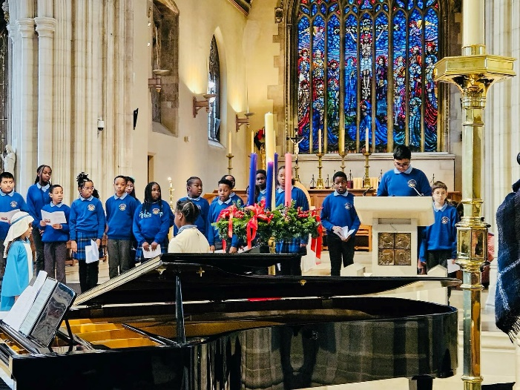


Welcome to:
St Francis RC Primary School

Dear Prospective Headteacher,
Thank you, on behalf of my fellow governors, for your interest in the post of Headteacher at St Francis RC Primary School.
The school was last inspected in June 2023 and was judged to be “Good” by Ofsted.
The school also underwent a denominational inspection, incorporating Section 48 and Canonical Inspection under Canon 806 on behalf of the Archbishop of Southwark in November 2022, and was judged to be “Outstanding”.

The governors believe that to secure the future success of the school, we need to appoint a practising Catholic Headteacher who will continue to build on the good practice and improvements already implemented by current our Headteacher.
The new Headteacher will bring fresh ideas and enthusiasm to drive school improvement and rapid progress opportunities for the pupils.
The new Headteacher will maintain and grow the Catholic ethos of the school, ensure compliance with directory changes and statutory guidance, particularly in relation the RSE.
Southwark School Improvement team provides School Improvement support for all maintained schools in the London Borough of Southwark and has a good working relationship with St Francis.
We positively encourage you to visit our school where you will receive a warm welcome from governors, staff and pupils.
Please detail in your application how you meet the person specification set out in the recruitment pack and how you intend to accomplish the key tasks detailed. Further information can be found on our school website http://www.stfrancispeckham.co.uk which will provide links to our latest Ofsted report, Section 48 Validation and 2025 KS2 data.
Yours faithfully,
Alan Carter
Chair of Governors

St Francis RC Primary School
Brother, Sister, Let Me Serve you


School Introduction
St Francis is a welcoming and vibrant school community where every child is encouraged to achieve their best. The governors are proud of the school’s success in promoting a culture of celebration of achievement in all areas, providing a friendly and inclusive environment, with a strong pastoral care system. We celebrate diversity and continue to build on the Health and Well-Being for all of our school community.
St. Francis RC Primary School is a one and a half form entry primary school at present.
The new building was built in 1970 on a site adjacent to the original St Francis School, which was a four-storey Victorian building.
The school is set in pleasant grounds which consist of gardens and three playgrounds - KS2, KS1 & Nursery.
A majority of our pupils at St. Francis are members of the parish of Our Lady of Sorrows, Peckham. Most children are Catholic and have one or both parents supporting their faith. We have a number of Christian children from other denominations and a small number from other faiths.
We are a popular choice for parents because of our caring ethos. St Francis RC Primary School exists to help the parents of this area to bring up their children in the Catholic Faith in the context of a good education. It is central to our mission that every child matters as a unique gift from God.

St Francis RC Primary School

Our Vision
Providing every child with the tools to choose their path to success.
Our Mission
In St Francis children succeed because:
- We are an outward looking Catholic Primary school, which welcomes all children from the surrounding area. We work together to nurture our pupils, helping them to become resilient and inspired learners, who will become responsible global citizens of the future.
- We cultivate our pupils through our broad and diverse curriculum and loving Catholic Parish community
- We provide a welcoming, safe and supportive environment that helps children feel respected, confident and motivated to achieve their goals.
- We also foster a spiritual and moral view of life that provides children with a sense of self-worth and a strong Catholic ethos
Our Gospel Values
Love
Honesty
Courage
Tolerance
Justice

Jeremiah 29:11
“I alone know the plans I have for you, plans to bring you prosperity and not disaster, plans to bring about the future you hope for”


St Francis RC Primary School

Key Information
Type of School | Primary
Age Range | 3 – 11 years
Number of Students on Roll | 253
% of SEND Pupils | 25%
% of EAL Pupils | 49% of the whole school with  26% speaking Spanish
% of Pupil Premium Pupils | 43%
Extra-Curricular Activities Offered | Football, Basketball, Multi-Sports, Choir
Breakfast and After School Care | Our Breakfast and After School service is provided by Magna Groups, who provide high quality care and activities for children using our indoor and outdoor facilities.
School Website | www.stfrancispeckham.co.uk
Parish Website | https://catholicpeckham.org.uk

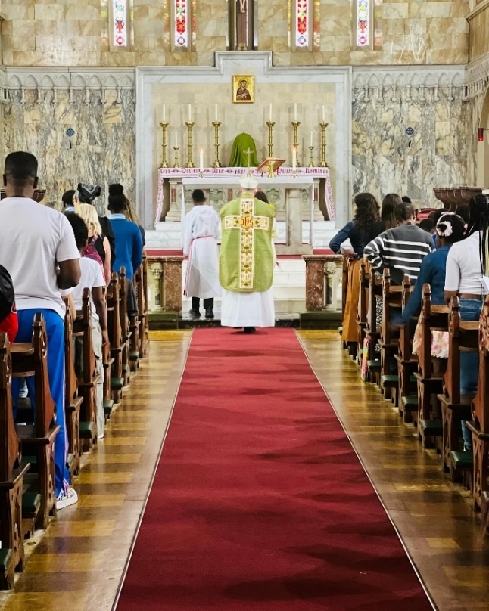
Our Community and Parish
St Francis RC Primary School enjoys a strong, active, and supportive relationship with its parish, which is led by the Norbertine Order. The parish plays a central role in the spiritual life of the school, working closely with staff, governors, pupils, and families to nurture a shared Catholic identity rooted in faith, service, and community.
The Norbertine Order, formally known as The Order of Canons Regular of Prémontré, is also widely referred to as the Norbertines, after their holy founder, St Norbert, and as the Premonstratensians, after their mother house in Prémontré, France. The Order follows the Rule of St Augustine and has a long tradition of pastoral ministry, education, and service to local communities.
Through regular worship, liturgical celebrations, sacramental preparation, and pastoral support, the parish and the Norbertine Fathers make a significant contribution to the life of the school. This close partnership enriches the spiritual development of pupils and supports families in their faith journey, ensuring that the Catholic mission and values of St Francis RC Primary School are lived out daily.
The school serves a richly diverse community, with a significant proportion of families for whom Spanish is their first language, and strong, inclusive communication with parents and carers is a key priority.
St Francis RC Primary School

Our location
St Francis RC Primary School
Friary Road, Peckham SE15 1RQ
0207 639 0187
office@stfrancis.southwark.sch.uk
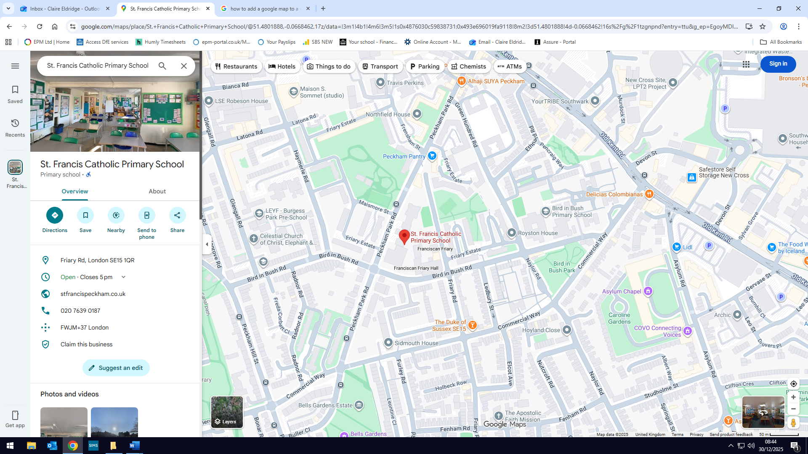

- Train – Queen’s Road, Peckham
Peckham Rye
- Tube – Elephant & Castle
- Bus – 78, 381, 63, 363 or any bus that serves the Old Kent Road
- The school also has a small car park for staff

St Francis RC Primary School

The successful applicant will be:
• A practising Catholic who has a clear understanding of the distinctive nature of a Catholic School and is willing to take an active role in the life & mission of the School
• An outstanding primary classroom practitioner
• An experienced school leader who is innovative and knowledgeable; confident to lead the school in line with the Bishop’s strategy for Catholic Education
• A strategic thinker who can develop and articulate an innovative, strategic vision for the school effectiveness, inclusion and wellbeing mindful of the impact of these on pupil outcomes
• Able to support, inspire and challenge staff
• Passionate about school improvement and raising standards
• Committed to build on existing relationships with parents, the Parish, the Diocese, Local Authority and wider community whilst fostering new relationships
• Able to identify strengths and weaknesses to further develop the potential of pupils and staff

We can offer you:
• A welcoming, Christ centred community with a strong Catholic ethos
• A real opportunity to make a difference to the lives of our children
• The chance to lead a dedicated and committed staff body
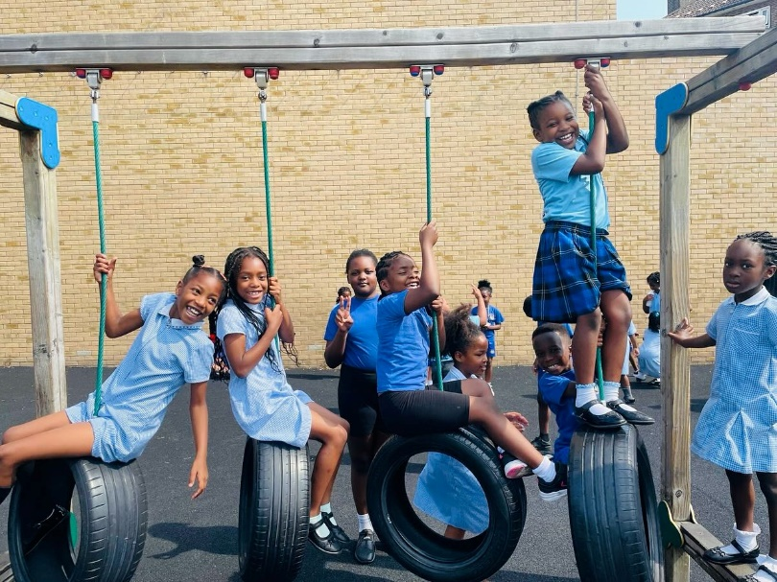
• A supportive Governing Body committed to raising standards and strong local parish links
• An exciting opportunity to further develop the School’s vision and successes
• Commitment to your continuous professional development

St Francis RC Primary School

Job Description
Job Title: Headteacher
Permanent Post
Group 2
Pay Range L15 (£82,888) – L21 (£93,556)

As a leader of a Catholic school community, a Headteacher:
- Serves in the best interests of the school’s pupils
- Conducts themselves in a manner compatible with their position in the Church and wider community by behaving ethically, fulfilling their professional responsibilities and modelling the values and virtues of a good citizen of the kingdom of God
- Uphold their duty to give account and accept responsibility
- Know, understand and act within the statutory frameworks which set out their professional duties and responsibilities
- Take responsibility for their own CPD, engaging critically with educational research to further the Church’s mission in education

The Headteacher is required to carry out professional duties as detailed in the job description, in Canon Law, the Trust Deed and Instrument of Government for the school and where applicable those set out in the current School Teachers’ Pay and Conditions document.
Specific responsibilities:
Shaping the future
The strategic direction and development of the school stems from the education mission of the Church which is reflected in the school’s mission statement, the school’s development and improvement plan and all policies and procedures.
• Work with the Diocese, parishes and others to create a shared culture and positive climate that reflects the mission of the Church in education.
• Ensure the shared vision for the school is clearly articulated, understood and effectively acted upon by all and demonstrated in everyday work and practice.
• Work within the school community to translate the vision into agreed objectives and operational plans which will promote and sustain school improvement.
• Motivate and works with others to create a shared culture and positive climate.
• Ensure creativity, innovation and the use of appropriate new technologies to achieve excellence.
• Ensure that strategic planning takes account of the diversity, values and experience of the school and community at large and the Church in education.
Principal responsibilities
The Headteacher will be responsible for the internal organisation, management and control of the school. This includes the national extended schools agenda in accordance with safeguarding legislation, the current School Teachers’ Pay and Conditions Document, the policies of the Governing Body (including its annual budget), applicable legislation and the policies of Southwark Local Authority.
The Headteacher, working with the Governing Body, leadership team and school staff, will develop a strategic view for the school in the context of its wider community and will ensure accurate school self-evaluation to inform school improvement planning. This job description should be read in conjunction with the National Conditions of Employment for Headteachers.
Leading learning and teaching
In a Catholic school the search for excellence is expressed in learning and teaching which responds to the needs and aspirations of all its pupils and acknowledges their individual worth as children of God.
• Develop, in consultation with the Governing Body, curriculum policies and practices that meet statutory requirements, are relevant to the aptitude and stages of development of all pupils, including those with special educational needs, provides for the spiritual, moral, cultural, social and emotional development of all pupils.
• Implement strategies which secure high standards of behaviour and attendance.
• Ensure that learning is at the centre of strategic planning and resource management.
• Establish creative, responsive and effective approaches to learning and teaching including the use of new and changing technology to enhance and extend the learning experience of all pupils and staff.
• Determine, organise and implement a diverse, flexible curriculum and implements an effective assessment framework.
• Ensure a consistent and continuous school- wide focus on pupils’ achievements, using data and benchmarks to monitor progress in every child’s learning.
• Monitor, evaluate and review classroom practice and promotes improvement strategies.
• Challenge underperformance at all levels and ensures effective corrective action and follow up.
• Ensure a culture of challenge and support, where all pupils can achieve success and become engaged in their own learning.
• Demonstrate and articulate high expectations and set stretching targets for the whole school community.
• Implement Diocesan policies on religious education, sex and relationship education and worship.
Leading and managing staff
In a Catholic school the role of the Headteacher is one of leadership of a learning community routed in faith. Christ is the inspiration for the Headteacher’s leadership.
The Headteacher’s management of staff should demonstrate an awareness of their unique contributions as individuals valued and loved by God.
• Assist the Governing Body in determining the staffing structure for the school.
• Treat people fairly, equitably and with dignity and respect to create and maintain a positive school culture.
• Develop and maintain effective strategies and procedures for staff recruitment, induction, professional development and performance review with regard to Diocesan guidance and advice.
• Acknowledge the responsibilities and celebrate the achievements of individuals and teams.
• Develop and maintain a realistic culture of high expectations for self and others and take appropriate action when performance is unsatisfactory.
• Regularly reflect on and review own practice, set personal targets and take responsibility for own personal development.
Securing accountability
The Headteacher supports the Governing Body in fulfilling its responsibility under Canon Law to the Diocese and in accordance with English Law.
• Fulfil commitments arising from contractual accountability to the Governing Body, including attendance at Governing Body meetings and reporting as required and assisting in its work as needed.
• Develop and maintain positive relationships with parishes, the wider Catholic community, other Catholic schools and other schools in the area and the Local Authority.
• Recognise the authority of the Archbishop in relation to the provision of Catholic education in the Diocese and to work with Diocesan authorities to provide them with such information as they require.
• Develop a Catholic ethos which enables everyone to work collaboratively, share knowledge and understanding, respect one another, celebrate success and accept and share responsibility for outcomes.
• Ensure individual staff accountabilities are clearly defined, understood and agreed and are subject to rigorous review and evaluation. Develop and present a coherent, and accurate account of the school’s performance to a range of audiences including governors, parents and carers, the Diocese and the local authority.
• Reflect on personal contribution to school achievements, takes account of feedback from others and provides opportunities for parents and carers to have dialogue and meetings with staff in the school to support their children’s learning.
Strengthening community
The Headteacher shares responsibility for the mission of the school and wider Diocesan education system and is therefore called to work in collaboration with others.
• Build a school culture and curriculum which takes account of the richness and diversity of the school’s communities and is rooted in the Catholic Christian Faith.
• Create and promote positive strategies for challenging racial and other prejudice and dealing with racial harassment.
• Ensure learning experiences for pupils are linked into and integrated with the wider community and liaises, where appropriate, with offsite learning providers to ensure an appropriate curriculum relevant to individual needs and aspirations.
• Collaborate with other agencies; clergy, religious, diocesan officers, colleagues, Headteachers of other schools and agencies set up by the Catholic Bishops’ Conference of England and Wales in providing for the academic, spiritual, moral, social, emotional and cultural well-being of pupils and their families.
• Create and maintain an effective, sensitive, partnership with parents and carers to support and improve pupils’ achievement and personal development.
• Seek opportunities to invite families, past pupils, community figures, businesses and other organisations into the school to enhance and enrich the school and its value to the wider community.
• Contribute to the development of the education system by sharing good practice, working in partnership with other schools and promoting innovative initiatives, especially with other Diocesan schools.
• Promote and develop the good reputation of the school within the local and wider communities.
• Build a school culture and curriculum which takes account of the richness and diversity of the school’s communities and is rooted in the Catholic Christian Faith.
• Create and promote positive strategies for challenging racial and other prejudice.
• Ensure learning experiences for pupils are linked into and integrated with the wider community and liaises, where appropriate, with offsite learning providers to ensure an appropriate curriculum relevant to individual needs and aspirations.
• Collaborate with other agencies; clergy, religious, diocesan officers, colleagues, headteachers of other schools and agencies set up by the Catholic Bishops’ conference of England and Wales in providing for the academic, spiritual, moral, social, emotional and cultural well-being of pupils and their families.
• Create and maintain an effective, sensitive, partnership with parents and carers to support and improve pupils’ achievement and personal development.
• Seek opportunities to invite families, past pupils, community figures, businesses and other organisations into the school to enhance and enrich the school and its value to the wider community.
• Contribute to the development of the education system by sharing good practice, working in partnership with other schools and promoting innovative initiatives, especially with other Diocesan schools.
• Promote and develop the good reputation of the school within the local and wider communities.
• Have the ability to communicate effectively in Spanish, or a clear willingness to develop Spanish language skills in order to support engagement with Spanish-speaking families within the school community.

Safeguarding
• Co-operate and work with relevant agencies to establish and maintain rigorous systems to protect children.
• Responsible for ensuring the welfare, health and well-being of all children and young people. Create a vigilant organisational culture which monitors and prioritises the safeguarding of children and young people above all considerations
Promoting equality and diversity
To treat everyone with dignity and respect.
To promote and participate to eliminate discrimination, advance equality of opportunity and faster good relations between our diverse communities.
Safer recruitment
The school is committed to safeguarding and promoting the welfare of children and young people and expects all staff and volunteers to share this commitment.

A Headteacher in the Archdiocese of Southwark
Section 1: Ethics and Professional Conduct.
Catholic Headteachers are expected to demonstrate consistently high standards of principled and professional conduct, inspired by Christ and demonstrate the qualities of character, fundamental to the Catholic tradition: faith, hope, love, justice, solidarity temperance, fortitude and practical wisdom. A Catholic Headteacher is expected to meet the teachers’ standards and be responsible for providing the conditions in which teachers can fulfil them.
In addition, a Catholic headteacher upholds and demonstrated the Seven Principles of Public Life, at all times. Known as the Nolan principles, these form the basis of the ethical standards expected of public office holders:
- Selflessness
- Integrity
- Objectivity
- Accountability
- Openness
- Honesty
- Leadership

A Catholic Headteacher is the custodian of a Catholic school and as such embodies the abundant hope of the Church has placed in education. A Catholic Headteacher is entrusted with the task of human formation in conformity with Christ and Church teaching, maintaining high standards of ethics and behaviour, both within and outside school.
A Catholic Headteacher:
- Builds relationships of mutual respect, rooted in the belief that all are made in the image and likeness of God and observe proper boundaries appropriate to their professional position.
- Will show tolerance and respect for the rights of others, recognising differences and respecting cultural diversity within contemporary society, enabling each person to play their full part in building and sustaining the Common Good.
- Will uphold British values, including democracy, rule of law, individual liberty and mutual respect, tolerance of those of different faiths and beliefs understanding that such values are rooted in the Catholic understanding of dialogue and Catholic Social Teaching.

Section 2: Headteacher Standards.
School Culture
- To establish and sustain a Christ centred vision embodied in the school’s Catholic mission, ethos and strategic direction in partnership with the parish and Trust (If appropriate), governors, the school community and Archdiocese.
- To create a Christ inspired culture where pupils experience a positive and enriching school life, enabling them to flourish.
- To uphold aspirational educational standards, which reflect the distinctive nature of Catholic education and which prepares pupils from all backgrounds for their future.
- To ensure a culture of professionalism based on mutual respect and the pursuit of excellence.

Teaching
- To establish and sustain high quality teaching, across all subjects and phases, built on evidence and research-based understanding
- To ensure teaching is underpinned by high levels of subject expertise and approaches which respect the distinct nature of the subject or specialism and demonstrates how each subject and discipline, contributing to the Christian vision of human flourishing.

Curriculum and Assessment
- To ensure a broad, structured and coherent curriculum entitlement, grounded in the distinctive characteristics of Catholic education which clearly sets out the knowledge, skills and values that will be taught.
- To establish and develop effective curricular leadership, developing the expertise of subject leaders, providing access to range of networks and communities.
- To ensure valid, reliable and accurate approaches are used when assessing pupils’ knowledge and understanding of the curriculum.
Behaviour:
- To develop and establish high expectations of behaviour, based on love, justice and reconciliation, built upon relationships and rules that are understood by all.
- To ensure high standards of behaviour through the promotion of the school’s values, ethos and mission, in accordance with the school’s behaviour policy.
- To adopt a consistent approach to the application of behaviour management.
SEND:
- To ensure the school holds ambitious expectations for all pupils with additional and special educational needs and disabilities in light of the principles of Catholic Social Teaching.
- To ensure the school works effectively in partnership with parents, carers, parish and professionals, to identify the needs of SEND children, providing support and adaptation where required.
- To ensure that the school fulfils its statutory duties with regards to the SEND code of practice.
Professional Development:
- To ensure that staff are provided with high quality CPD, in all areas of practice and that is aligned to the school development areas.
- To make sure that all CPD is strategically planned, sequenced and evaluated. That is is consistent with the approaches laid out in the standards for teachers’ professional development
- To draw on experts to provide high quality CPD, including diocesan and nationally recognised career and professional frameworks and programmes.
- To ensure the building of capacity and to support succession planning.

Organisation and Management:
- To have an effective approach to safeguarding, to ensure the protection and safety of both staff and pupils.
- To allocate and prioritise financial resources, ensuring efficiency, probity and effectiveness. The use of public funds should reflect the school’s Catholic mission.
- To ensure a good work/life balance for staff, through effective management and deployment.
- To develop and oversee systems, processes and policies that enable the school to operate effectively, where there is a clear understanding of the Church’s mission in education.
- To have a robust approach in identifying, managing and mitigating any risks
Continuous School Improvement:
- To identify, evaluate and analyse any persistent problems and barriers which limit the effectiveness of the school, identifying key areas for improvement.
- To develop evidenced based and well-targeted plans that are both timely and realistic and which are suited to the school’s Catholic context.
- To ensure careful and effective implementation of improvement strategies, which lead to improvement over time.

Working in Partnership:
- To develop strong relationships with the wider community, working in partnership with parents, carers, the parish, diocese and the local community.
- To develop the network of Catholic schools, other schools and organisations, in a spirit of challenge and support.
- To develop relationships with other professionals in a range of public services, to improve the educational outcome for all pupils.

Governance and Accountability:
- To embrace the contribution of effective governance, rooted in strategic stewardship of Catholic mission in education, upholding the obligation to give account and accept responsibility.
- To develop and nurture a professional and appropriate relationship with governors which is inspired by a Christ centred vision for human formation.
- To ensure that staff are clear on their professional responsibilities and that they are held to account.
- To ensure that the school operates within the required regulatory frameworks and meets all of its statutory duties.

Based on the 2020 DfE Headteachers’ Standards. These have been amended to reflect the distinctive nature of Catholic leadership and the role of a Catholic leader in upholding the mission of the Church.

Person Specification for a Headteacher at St Francis RC Primary School
Introduction
- The status of the school and where it sits as part of the diocese, with a focus on the Memorandum and Articles
- The purpose of the person spec
- What is required from a candidate, the qualities and skills for leadership in a Catholic school?
- What the school can offer any successful candidate and what level of experience the school are looking for, an experienced headteacher or someone new to the role.
- What are the expectations regarding qualifications; NPQH or CCRS

Definition of a practising Catholic from Christ at the Centre
Therefore, for appointment as a member of the governing authority of a Catholic school or to key posts within the school, a ‘practising Catholic’ is to be defined as someone who has been sacramentally initiated into the Catholic Church and who adheres to those substantive life choices which do not impair them from receiving the sacraments of the Church and which will not be in any way detrimental or prejudicial to the religious ethos and character of the school. Inspired by the Gospel and sustained by God’s grace, a ‘practising Catholic’ will give sincere external expression to their interior faith through specific religious, moral and ethical behaviour which is in accordance with the teaching of Christ and the Catholic Church.

Person Specification
Qualities and Knowledge | Essential or Desirable | Evidence
A practising Catholic, evidenced by a priest reference | E | I/R
Qualified Teacher Status | E | A
Degree | E | A
NPQH or similar | D | A
CCRS | D | A
Teaching and leadership experience in one or more Catholic primary/secondary schools | D | A/I/R
Ability to communicate effectively in Spanish, or a clear willingness to develop Spanish language skills in order to support engagement with Spanish-speaking families within the school community | D | A/I
Lead by example and be a positive role model with excellent communication skills | E | I/R
Ability to articulate a clear vision and purpose for Catholic education and to share their Catholic faith with a range of colleagues who may or may not be Catholic | E | A/I/R
Personal impact and presence | E | I/R
Participation in a parish community | E | A/I/R
Ability to lead the spiritual development of staff and pupils | E | I/R
Understand the current educational provision and the wider school systems | E | A/I
Political and financial astuteness | E | A/I/R
Demonstrate and experience of working alongside clergy and faith leaders. | E | A/I/R
Pupils and Staff | Essential or Desirable | Evidence
Have ambitious standards and high expectations for all pupils | E | A/I/R
Excellent understanding of high quality teaching and learning | E | A/I/R
Promote the development of the whole child | E | A/I/R
Use data analysis to effectively drive whole school improvement | E | A/I/R
Encourage staff and pupils to develop their unique potential, character | E | A/I/R
Identify emerging talent, develop excellence and clear succession planning | E | A/I/R
Systems and Process | Essential or Desirable | Evidence
Effective strategic leadership and astute and understanding of school finance | E | A/I/R
Ensure the safety of all staff and pupils, at all times | E | A/I/R
Promote excellent behaviour and positive attitudes to school life | E | A/I/R
Systems for appraisals to hold all staff to account | E | A/I/R
Skills to challenge underperformance | E | A/I/R
Understanding the importance of strong governance to hold the school to account | E | A/I/R
Ensure value for money in deploying resources and budgets, for the best outcomes for all | E | A/I/R
Promote distributive leadership throughout the school | E | A/I/R
School Improvement | Essential or Desirable | Evidence
Knowledge and experience of working with other schools and organisation | E | A/I/R
Develop effective partnerships with other professionals | E | A/I/R
Use evidence-based research to achieve excellence | D | A/I/R
Provide opportunities for high quality staff development | E | A/I/R
A confident and innovative approach to school improvement | E | A/I/R
Provide inspiration and encouragement for all members of the community | E | A/I/R
Child Protection | Essential or Desirable | Evidence
Ensure all CP policies and procedures adopted by governors are fully implemented and adhered to by staff | E | A/I/R
Ensure that sufficient resources and time are allocated to enable staff to perform their CP related responsibilities effectively | E | A/I/R
Securing Accountability | Essential or Desirable | Evidence
Fulfil all commitments arising from contractual accountability to the governing body | E | A/I/R
Ensure individual staff accountabilities are clear, understood, agreed, reviewed and evaluated | E | A/I/R
Work with the governing body to enable it to meet its statutory responsibilities | E | A/I/R
Develop an accurate and understandable account of the school’s performance for a range of stakeholders | E | A/I/R
Personally contribute to school achievement, taking account of feedback from others | E | A/I/R
Strengthening the Community | Essential or Desirable | Evidence
Build a culture and curriculum which takes account of the richness and diversity of the community’s Catholic faith | E | A/I/R
Create and promote strategies for challenging racial and other prejudices | E | A/I/R
Ensure that learning experiences are enriching and are linked into and integrated with the wider community | E | A/I/R
Collaborate with agencies in providing for the academic, spiritual, moral, social, emotional and cultural wellbeing of all | E | A/I/R
Develop and maintain an effective partnership with parents and carers | E | A/I/R
Share effective practice, working in partnership with other schools | E | A/I/R
Application Form and Letter | Essential or Desirable | Evidence
The appropriate form to be completed in full and legible | E | A
Supporting statement to be clear, concise and related to the post being applied for and appointment criteria (No more than 2 sides of A4 in font size 11) | E | L
Confidential References and Reports | Essential or Desirable | Evidence
A positive and supportive written faith reference from a priest where the applicant regularly worships | E | R
A positive recommendation from current employer or Headteacher | E | R
A second professional reference | E | R

A – Application | I – Interview | R – References | L - Letter


Headteacher Wellbeing Offer

The Offer:
The service is:
- Designed and structured to meet the needs of Headteachers in the Archdiocese
- A confidential provision for Headteachers in all phases
- An opportunity to talk confidentially on a personal and professional basis
- Created to facilitate and nurture links with other Headteachers and professionals
The Aims of the Service:
The service:
- Promotes the wellbeing of Headteachers in the Archdiocese
- Provides support for individual Headteachers
- Assists the Headteacher in the resolution of issues
- Enables the development of networks
- Supports the development of networks and relationships between Headteachers, Governors and diocesan and local authority personnel

The role of the Archdiocese
- The Archdiocese is committed to supporting Headteachers in their role and to working in partnership with it trusts and schools
- The Education Service acts as the agent in the employment of a coordinator for Headteacher wellbeing

