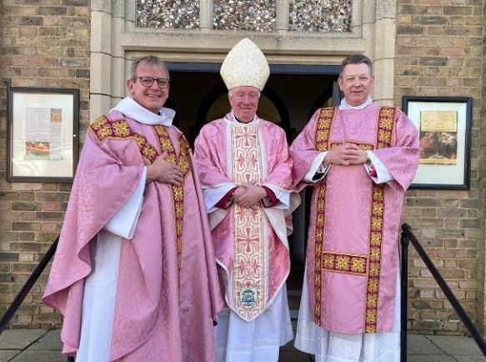

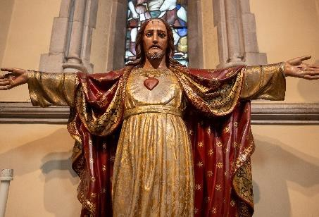
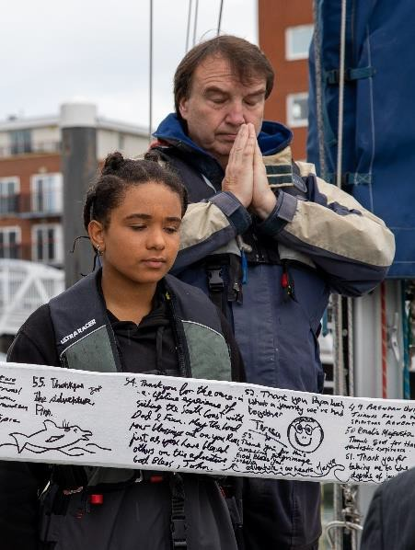
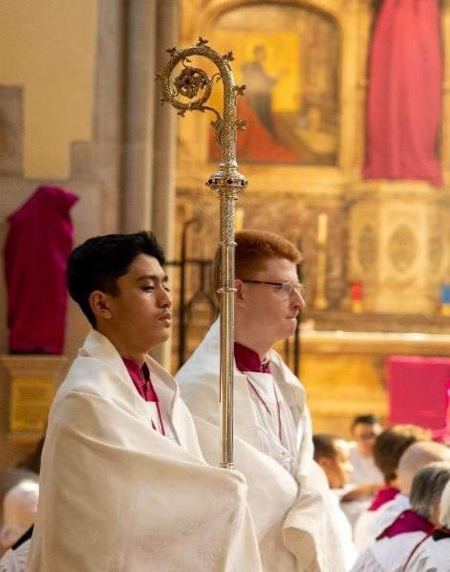
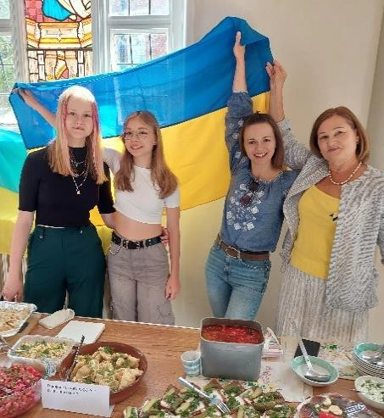
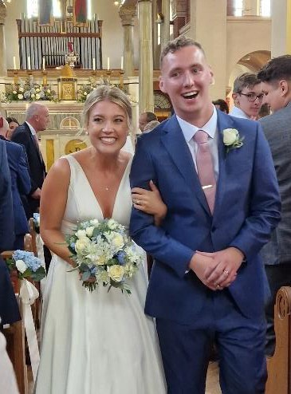
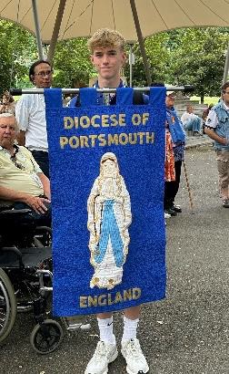
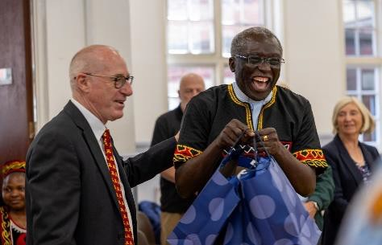
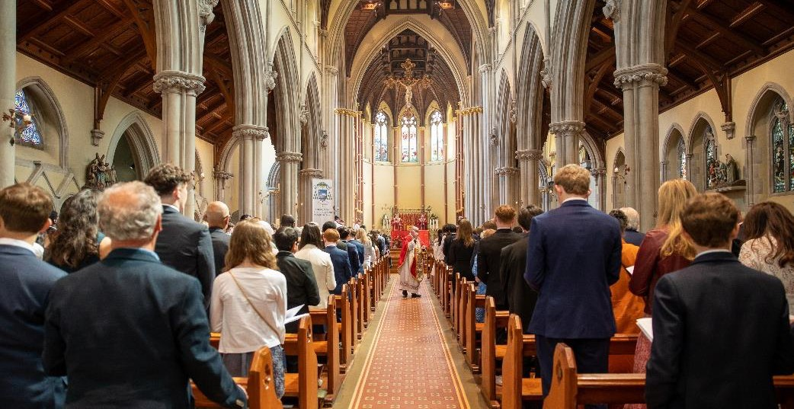

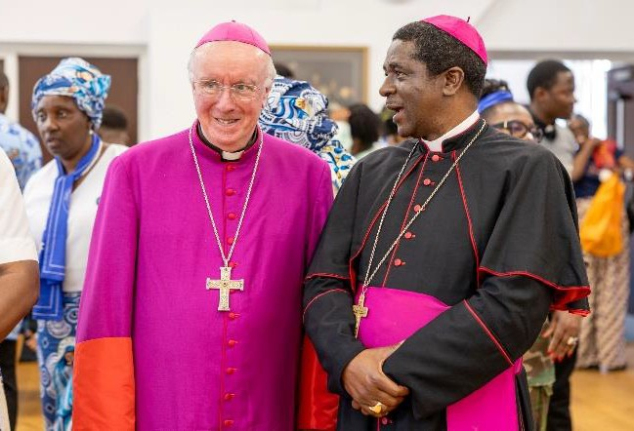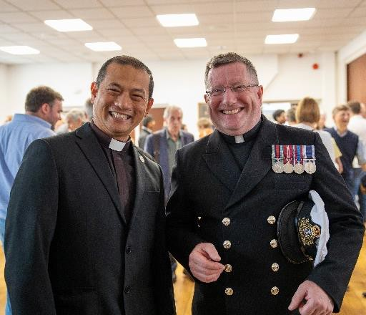

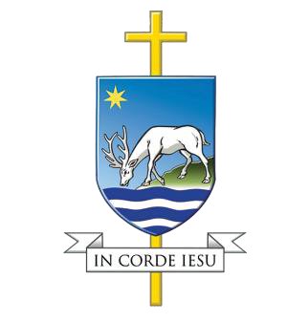
Clergy Formation Lead
APPLICANT BRIEFING PACK
November 2025

ABOUT THE CATHOLIC DIOCESE OF PORTSMOUTH

Our Diocese

We are the Diocese of Portsmouth, governed by the Bishop of Portsmouth, Bishop Philip Egan. We belong to the One, Holy, Catholic Church, which is led by the Bishop of Rome, Pope Leo XIV.

The Diocese of Portsmouth
Our Diocese is spread across five counties on England’s South Coast, and the Channel Islands. We are the local Church for the whole of Hampshire, Berkshire, the Isle of Wight, Jersey, and the Bailiwick of Guernsey as well as the Southern Part of Oxfordshire and the Eastern part of Dorset.
We are made up of 87 Parishes in 24 Pastoral Areas, for a total of 136 Churches. We have 115 priests, 40 Deacons, 35 houses of religious brothers and sisters, and a Catholic population of more than a quarter of a million.

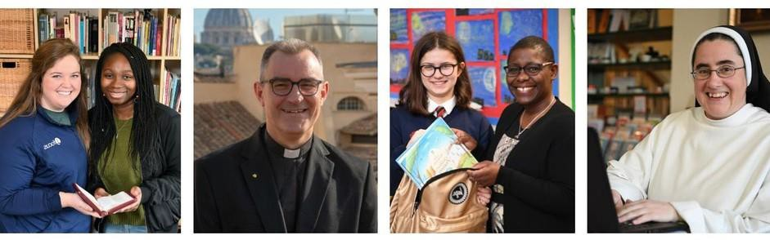
We belong to the province of Southwark, which covers the whole south coast from Kent to Cornwall. Our Metropolitan is the Archbishop of Southwark. Our province also includes the Archdiocese of Southwark, the Diocese of Arundel and Brighton, and the Diocese of Plymouth.

Ten-Year Mission Plan
You Will Be My Witnesses in summary

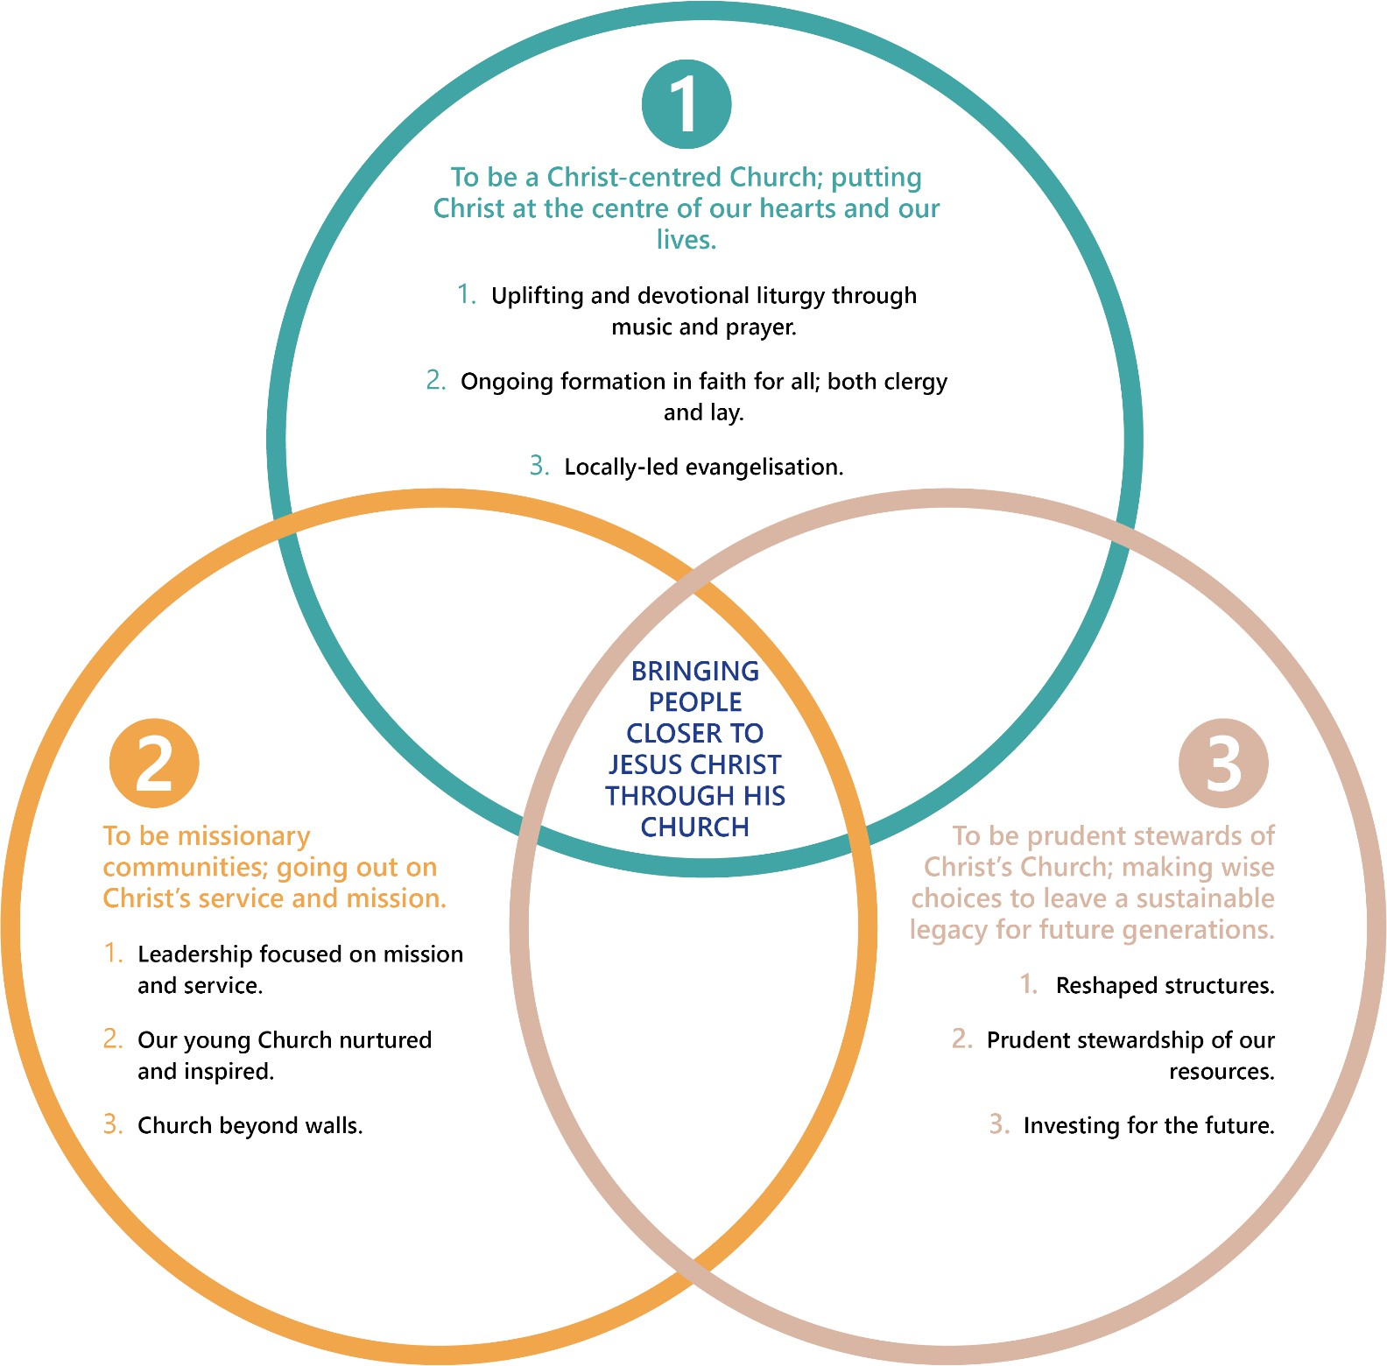

Role Purpose
The Catholic Diocese of Portsmouth is seeking a Clergy Formation Lead to work closely with the Vicar for Clergy in shaping and delivering a comprehensive programme of ongoing formation. This pivotal role will ensure that clergy development reflects pastoral priorities, fosters personal and spiritual growth, and meets the highest standards of pastoral care and professional practice.

The postholder will take a lead role in designing and implementing a diocesan framework for Personal Growth and Development Plans (PGDPs)—helping priests deepen their spiritual life, strengthen their pastoral and leadership skills, and engage in continued theological reflection. Working collaboratively across diocesan departments and with external partners, you will also coordinate training, retreats, mentoring, and induction programmes that nurture the spiritual, intellectual, and pastoral vitality of the presbyterate.

We are seeking an experienced professional with a background in theology, education, or leadership development, and a deep understanding of the life and ministry of the Church. You will be highly organised, compassionate, and skilled at building trusting relationships. This is an opportunity to make a lasting contribution to the life and mission of the Diocese.

This is an exciting time to join our friendly, busy, and supportive team as we implement our 10-year Mission Plan, shaping the future of our Diocese and the communities we serve.

Covering Hampshire, Berkshire, South Oxford, and the Channel Islands, our Diocese is home to 87 parishes and 50 schools, serving over 27,000 practising Catholics and supporting 32,000 children and their families. Our work is both challenging and deeply rewarding, offering the opportunity to be part of something truly meaningful.

Key Internal and External Relationships
- Parish Priest
- Priests and Deacons across the Pastoral Area
- Parish Finance Administrator
- Parish volunteers and employees
- Parishioners and visitors, including, those with special responsibility and needs (e.g. bereaved, homeless etc)
- Diocesan Curia departments (Finance, HR, Estates, Safeguarding, Communications, and Governance)
- Local schools, Polish community centre and University chaplaincy
- Church leaders of other denominations or faiths
- External suppliers and contractors

Main Duties
Develop a Framework for Personal Growth and Development
- Devise a clear and structured Personal Growth and Development Plan (PGDP) for individual clergy, based on Pastores Dabo Vobis and Ratio Fundamentalis.
- Establish a system to support each priest in setting realistic and measurable goals within three key domains:
  - Spiritual growth and pastoral effectiveness (e.g., prayer life, pastoral charity, homiletic skill, sacramental ministry).
  - Intellectual and theological development (e.g., continued theological study, reflection on Church teaching).
  - Leadership and administrative competence (e.g., parish leadership, safeguarding, communication, financial stewardship).
- Create tools and templates (self-assessment forms, reflection guides, development review forms) to track progress and provide feedback.

Support Implementation of Personal Growth Plans
- Roll out PGDP across the presbyterate, starting with newly ordained priests and those needing specific support.
- Coordinate accompaniment and mentoring systems, pairing priests with mentors, spiritual directors, or peer groups.
- Provide guidance and training for clergy on using the development plan for self-reflection and growth.
- Maintain confidential records of engagement and progress.

Identify and Coordinate Training and Formation Resources
- Conduct bi-annual training needs analysis based on clergy feedback and diocesan priorities.
- Source, design, and deliver formation opportunities (workshops, retreats, online modules).
- Collaborate with seminaries, universities, and Catholic agencies for accredited content.
- Maintain an annual clergy formation calendar and oversee communication, booking, and evaluation.

Induction and Onboarding
- Coordinate and deliver induction training for priests newly appointed to the Diocese, including those from overseas.

Collaborate with Key Diocesan Personnel
- Liaise with departments (Safeguarding, HR, Finance, Property, Education) to integrate essential training.
- Support the Vicar for Clergy in induction programmes.
- Contribute to reports for the Bishop and Council of Priests.
- Build links with neighbouring dioceses and national networks.

Adapt Methods for Delivery
- Design and deliver training using face-to-face, online webinars, and digital resources.

Monitor, Evaluate and Develop the Programme
- Establish evaluation systems and collect feedback.
- Review formation strategy annually and propose improvements.
- Stay updated on developments in priestly formation and leadership.

Budget Management
- Define, manage, and work within agreed budgets in line with diocesan policies.

Professionalism and values
- Uphold and promote the ethos and values of the Catholic Church.
- Work collaboratively with the Parish Administrator and other key members of the parish to ensure the Parish Priest is effectively supported.
- Foster a welcoming and professional parish environment for clergy, volunteers, and parishioners.
- Maintain confidentiality and discretion.

Parish Administrator – Person Specification

Competence, Expertise and Knowledge:
Essential | - A degree (or equivalent professional qualification) in one or more of the following areas:  - Theology, Religious Studies, or Pastoral Ministry  - Education, Adult Learning, or Training & Development  - Leadership, Coaching, or Organisational Development  - Evidence of continuing professional development relevant to adult formation, mentoring, or reflective practice.  - Proven experience in designing, delivering, or coordinating personal and professional development programmes, ideally within a Church, charity, education, or formation context.  - Demonstrated experience in supporting adult learning and reflective practice, such as mentoring, coaching, or training delivery.  - Strong understanding of the theology and values of the Roman Catholic Church, with respect for its mission, structures, and spiritual traditions.  - Awareness of the spiritual, pastoral, and practical realities of priestly and diaconal life, with the ability to respond sensitively to clergy formation needs.  - Experience in building and maintaining effective relationships with a diverse range of people, including clergy, lay staff, and external partners.  - Experience in project management, including planning, delivery, and evaluation of multiple activities or training events.  - Ability to collect and analyse feedback to inform programme improvement and demonstrate outcomes.  - Sound understanding of safeguarding principles, data protection, and confidentiality when working with clergy and sensitive personal information.
Desirable | - Postgraduate qualification (e.g., MA in Pastoral Theology, Leadership in the Church, or Adult Education).  - Recognised qualification in coaching, mentoring, or spiritual accompaniment (e.g., ILM Coaching, Spiritual Direction training, or similar).  - Previous experience working within a diocesan, parish, or religious organisation, or other faith-based setting.  - Experience in facilitating formation or training for priests, deacons, or church leaders, or equivalent experience with adult professionals in pastoral or educational roles.
Skills and Competencies | - Excellent interpersonal and communication skills, both written and verbal, with the ability to inspire trust and openness.  - Highly organised, able to prioritise and manage a varied workload with competing deadlines.  - Skilled at facilitating group sessions and reflective discussions with empathy and professionalism.  - Strong analytical and problem-solving abilities, able to identify and address emerging needs creatively.  - Competent in Microsoft Office applications (Word, Excel, PowerPoint) and confident using digital tools for learning delivery and event coordination.  - Demonstrates discretion, integrity, and sound judgement, maintaining strict confidentiality.  - Flexible, adaptable, and committed to collaborative working across departments.  - Commitment to equality of opportunity, inclusion, and the respectful treatment of all.

Salary, Benefits & Location

Salary: £24,723 pro-rata (£44,150 FTE)

Contract: Permanent

Hours: 21 hours per week

Location: 61A Yorktown Road, Sandhurst, Berkshire, GU47 9BS

Reports to: Fr Paul Leonard

Direct Reports: Canon David Hopgood (Vicar for the Clergy)

Benefits
25 days holiday plus bank holidays (pro-rata)
Life Assurance and Employee Wellbeing
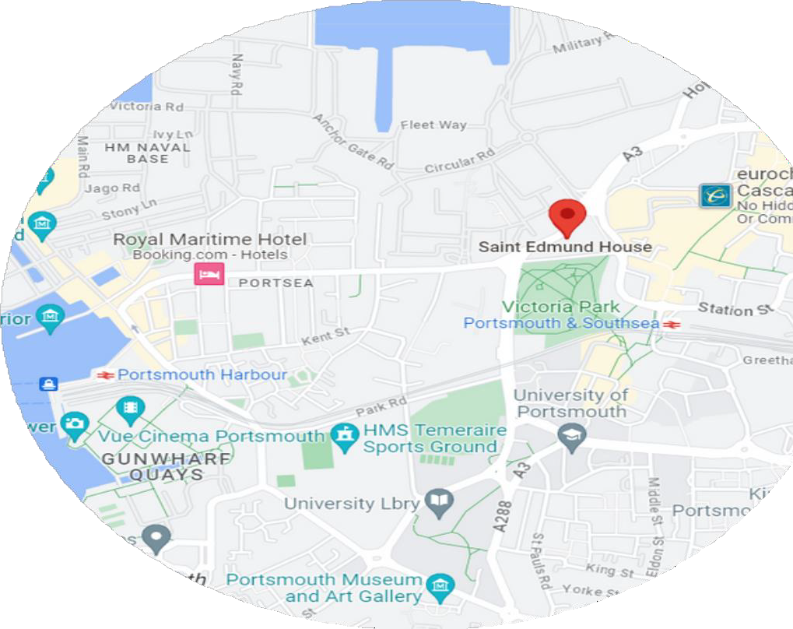
Contributory pension scheme with Scottish Widows
Free on-site parking

Head Office

St. Edmund House,

Bishop Crispian Way,

Portsmouth,

PO1 3QA

How to Apply
Please send a comprehensive and up to date Curriculum Vitae along with a covering letter setting out your suitability for the role and motivation in applying (no more than 2 sides A4) to recruitment@portsmouthdiocese.org.uk Please state ‘Clergy Formation Lead’ in the subject line of your email.

The Diocese of Portsmouth is an equal opportunity employer and welcomes applications from all who support the ethos and values of the Catholic Church.

We encourage an early application as we may close this advertisement at our discretion before the date stated, if a high number of applicants apply.

The closing date for applications is 2nd March 2026.

Interview Information
You will be notified shortly after the closing date, should we wish to progress your application and invite you to an interview.
Interviews will be held on 26th March 2026.

Appointment
Any offer of employment to work at the Catholic Diocese of Portsmouth is conditional upon receipt of two satisfactory employment references, provision of relevant certification of qualifications held, and completion of pre-employment checks.

You must have a valid UK Right to Work, as the Catholic Diocese of Portsmouth does not offer UK Visa Sponsorship.
